Add/Edit Gp2Edit File

You can add a Gp2Edit dos patch file to your track set and export this at the same time as you export your tracks. To make a Gp2Edit dos patch file open Gp2Edit and your *.gp2 file and select “Create DOS Patch” in the Options menu. To add the file to your track set select “Add/Edit Gp2Edit File…” from the Tools menu in Gp2 Track Handler and then select the *.exe file you created with Gp2Edit. When you have added the Gp2Edit file to your track set you will get this screen.

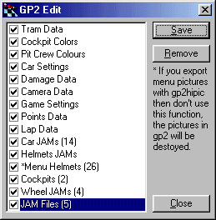
(Gp2Edit Dos Patch File)

To export an item check the checkbox next to the item, if you don’t want to export one item uncheck the checkbox in front of the item. The numbers you se between parentheses is the number of this item there are e.g. there are 14 car jams and 26 menu helmets in this file above. To save the changes you make click “Save” and to remove the Gp2Edit file from your track set click the “Remove” button. When you have added a Gp2Edit file and want to access this screen to edit the settings select “Add/Edit Gp2Edit file…” in the Tools menu.

